

JAVA PROJECT REPORT ON
Online Order Processing and Invoice Generation System

Submitted by
Navya.N
25BIT129

Under the Guidance of
Mugilan.R
Technical Trainer
Technical Department, KG College of Arts and Science

Academic Year: 2025 – 2026
APRIL 2026
Semester: II

DECLARATION
I hereby declare that the project entitled “Online Order Processing and Invoice Generation System” submitted in partial fulfillment of the requirements for the course java programming is a record of my original work carried out under the guidance of [Mugilan.R], Technical Trainer, Technical Department, KG College of Arts and Science.
I further declare that this project has not been submitted previously, either in part or in full, for the award of any degree, diploma, or other similar title, at this or any other institution.
I have acknowledged all sources of information used in this project wherever applicable.

April 2026
Coimbatore

Navya.N

CERTIFICATE
This is to certify that the project entitled “Online Order Processing and Invoice Generation System” is a bona fide work carried out by Navya.N, [BSC.IT “B” (2025-2028) ], B.Sc.INFORMATION TECHNOLOGY, KG College of Arts & Science, in partial fulfillment of the requirements for the course JAVA PROGRAMMING
This project has been completed under my supervision and guidance during the academic period April 2026.

Place: Coimbatore
Date:

Submitted for the Viva-Voce Examination held on __________________________________

Guide: Head of the Department
(Technical Trainer, KGCAS) (Technical Head, KGCAS)

______________________ _______________________

TABLE OF CONTENTS
S. No. | Topics | Page. No.
1 | Introduction
1.1 | Objective
1.2 | Overview
1.3 | Features
2 | Program Analysis
2.1 | Problem Definition
2.2 | Project Overview
2.3 | Scopes and Limitations
3 | System Design
3.1 | Modules
4 | Methodology
4.1 | Problem Analysis
4.2 | System Design
4.3 | Program Development
4.4 | Testing and Validation
4.5 | Result and Documentation
4.6 | Algorithm
4.7 | Flowchart
5 | Source Code
6 | Input and Output Screens
7 | Discussion and Conclusion
7.1 | Discussion
7.2 | Conclusion
8 | References

ABSTRACT
The Online Order Processing and Invoice Generation System is a Java-based application developed to automate the process of placing orders and generating invoices in online shopping environments. In many small businesses, order processing and billing are still handled manually, which can lead to calculation errors, delays in processing orders, and difficulty in maintaining accurate records. This project aims to simplify and streamline the order management process by providing an automated system that processes customer orders and generates an accurate invoice.
The system allows users to select products from a predefined product list, enter the quantity of each item, and automatically calculate the total cost of the order. It then generates a structured invoice displaying details such as product name, quantity, price, subtotal, applicable taxes, and the final payable amount. The application is developed using Core Java programming concepts, including classes, objects, methods, loops, conditional statements, and exception handling. The project can be implemented as a console-based application or enhanced using Java Swing to provide a graphical user interface.
The main objective of the system is to improve the efficiency of order processing, reduce manual errors, and provide faster and more reliable service to customers. The system generates a clear and organized invoice that helps both customers and businesses maintain accurate transaction records.
This project demonstrates the practical implementation of object-oriented programming concepts in Java and provides a foundation for developing more advanced e-commerce and online order management systems in the future.

- INTRODUCTION
In today's digital world, online shopping and electronic transactions have become an important part of modern business operations. Many businesses sell products through online platforms where customers can place orders and receive invoices automatically. However, in some small businesses, order processing and billing are still performed manually using paper records or simple calculators. This manual approach can lead to calculation errors, delays in order processing, and difficulties in maintaining transaction records.
With the advancement of computer technology, automated order processing systems have become essential for improving efficiency and accuracy in business operations. A computerized order processing system allows businesses to manage customer orders, calculate the total amount automatically, and generate invoices quickly and accurately.
The Online Order Processing and Invoice Generation System is a Java-based application designed to automate the process of order management and invoice generation for online purchases. The system allows users to select products from a predefined product list, enter the quantity of items, and automatically calculate the total cost including applicable taxes. The application then generates a structured invoice displaying product details, quantities, prices, subtotal, tax, and final payable amount.
This project is developed using Core Java programming concepts such as classes, objects, methods, loops, conditional statements, and exception handling. The application can be implemented either as a console-based program or using Java Swing to create a graphical user interface (GUI).
The main goal of this system is to simplify order processing, reduce manual errors, and provide faster invoice generation for businesses and customers. This project also demonstrates how Java programming can be used to develop practical applications for real-world business environments.

1.1 Objective
The main objective of the Online Order Processing and Invoice Generation System is to develop a simple and efficient Java-based application that automates the process of managing online orders and generating invoices.
The specific objectives of this project are:
• To design and develop a Java-based order processing system.
• To automate the calculation of product prices and total order amount.
• To reduce manual errors in order processing and billing.
• To provide a user-friendly system for generating invoices quickly.
• To demonstrate the implementation of Core Java programming concepts such as classes, objects, loops, and conditional statements.
• To generate a clear and organized invoice for customers.

1.2 Overview
The Online Order Processing and Invoice Generation System is a menu-driven application developed using the Java programming language. The system provides a digital platform where users can select products from a predefined list and generate invoices automatically.
The system displays a list of available products along with their prices. The user can select the required items and enter the quantity for each product. The program then calculates the total price for each item and generates a final invoice including applicable taxes such as GST.
The system simplifies the order processing process by eliminating manual calculations and reducing the chances of billing errors. The application can be implemented as a console-based program or as a graphical user interface using Java Swing.
This project demonstrates the practical use of Java programming in developing real-world applications for small businesses and online retail systems.

1.3 Features
The Online Order Processing and Invoice Generation System includes the following main features:
• Product Display – Displays a list of available products along with their prices.
• Order Selection – Allows the user to select products and enter the quantity.
• Automatic Price Calculation – Automatically calculates the total cost based on selected items and quantities.
• Tax Calculation – Calculates applicable taxes such as GST and adds them to the total amount.
• Invoice Generation – Generates a detailed invoice showing product names, quantities, prices, subtotal, tax, and final amount.
• User-Friendly Interface – Provides a simple and easy-to-use menu-driven interface.
• Fast Order Processing – Reduces the time required to generate invoices.

- PROGRAM ANALYSIS
Program analysis is an important stage in software development where the problem is studied and system requirements are identified. This phase helps in understanding how the system should function and what features are required to solve the problem effectively.
The analysis phase focuses on identifying the problems in the existing system and designing a computerized solution that improves efficiency and accuracy.
2.1 Problem Definition
In many small businesses, customer orders and billing are still managed manually using paper records or calculators. This traditional approach can create several problems.
Some common issues include:
• Errors in order calculation
• Time-consuming billing process
• Difficulty in managing multiple orders
• Lack of proper transaction records
• Slow customer service during busy hours
Manual systems also increase the workload for staff and may lead to customer dissatisfaction due to delays or incorrect invoices.
Therefore, an automated system is required to process orders efficiently and generate accurate invoices.
The Online Order Processing and Invoice Generation System is designed to solve these problems by providing a computerized solution that automates order processing and billing.
2.2 Project Overview
The Online Order Processing and Invoice Generation System is a Java-based application designed to simplify the order management and billing process.
The system provides a menu-driven interface where users can select products from a predefined list and specify the quantity of each item ordered. The system automatically calculates the total price of the selected items and generates a final invoice.
The system includes the following functionalities:
• Displaying the product list with prices
• Selecting products and entering quantity
• Automatically calculating item cost
• Computing subtotal and tax amount
• Generating the final invoice for the customer
This project is implemented using Core Java programming concepts and can be developed as either a console-based application or a GUI-based application using Java Swing.
2.3 Scopes and Limitations
Scope
The scope of the Online Order Processing and Invoice Generation System includes:
• Managing product information
• Processing customer orders
• Automatically calculating the total order amount
• Generating a detailed invoice for customers
• Demonstrating the practical use of Java programming concepts
The system can be used in:
• Online stores
• Retail shops
• Small businesses
• E-commerce applications
• Billing systems for product sales

3.SYSTEM DESIGN
System design is the phase where the structure and components of the system are planned before implementation. This stage helps organize the program and define how different modules will work together.
The Online Order Processing and Invoice Generation System is designed as a menu-driven application where users can select products, enter quantities, and generate invoices automatically

3.1 Modules
1. Product Display Module
This module displays the list of available products along with their prices.
Example Menu:
- Laptop – ₹50000
- Mobile Phone – ₹20000
- Headphones – ₹2000
- Keyboard – ₹1500
- Mouse – ₹500
The product list helps the user select items easily.

2. Order Selection Module
This module allows the user to select products and enter the quantity.
Functions include:
• Accepting product selection
• Accepting quantity input
• Storing order details temporarily
Users can select multiple products before generating the final invoice.

3. Bill Calculation Module
This module performs all billing calculations.
The system calculates:
• Total price of each product
• Subtotal of all items
• Applicable tax (GST)
• Final payable amount
Example Calculation:
Item Total = Price × Quantity
GST = 5% of Subtotal
Final Bill = Subtotal + GST

4. Invoice Generation Module
This module generates the final invoice.
The invoice includes:
• Product name
• Quantity
• Price
• Subtotal
• GST amount
• Final amount

Example Output:
------ INVOICE ------

Item Qty Price
Laptop 1 50000
Mouse 2 1000

Subtotal 51000
GST (5%) 2550
Total 53550

Thank You for Your Purchase!

5. Exit Module
This module allows the user to safely exit the application after completing the order process.

This module allows the user to exit the application safely after completing the billing process.
When the user selects the exit option, the system terminates the program.

4.METHODOLOGY
Methodology describes the process followed during the development of the project.
The development process includes:
• Problem Analysis
• System Design
• Program Development
• Testing and Validation
• Result and Documentation

4.1. Problem Analysis
In this phase, the problems in manual order processing systems are studied.
Common problems include:
• Manual calculation errors
• Slow billing process
• Difficulty handling multiple orders
• Lack of proper order records
Based on these issues, an automated system is designed.

4.2. System Design
The system is divided into modules:
• Product Display Module
• Order Selection Module
• Bill Calculation Module
• Invoice Generation Module
• Exit Module

4.3. Program Development
The system is developed using Java programming language.
The development process includes:
• Creating classes and methods
• Implementing menu-driven logic
• Writing billing calculation code
• Accepting user input
• Displaying the final invoice

4.4. Testing and Validation
Testing ensures the program works correctly.
Example Test Cases:
Test Case |  |  |  | Expected Result
Select product |  |  |  | Product displayed correctly
Enter quantity |  |  |  | Quantity accepted correctly
Calculate bill |  |  |  | Correct total displayed
Invalid input |  |  |  | Error handled properly

4.5. Result and Documentation
After successful testing, the system generates invoices based on selected products and quantities.
Screenshots of program input and output are included for documentation.

4.6. Algorithm
Algorithm for the Online Order Processing and Invoice Generation System:
- Start the program.
- Display the product list with prices.
- Ask the user to select a product.
- Enter the quantity of the product.
- Calculate the total cost of the item.
- Add the cost to the subtotal.
- Repeat steps 3–6 for additional products.
- Calculate GST or tax amount.
- Calculate the final invoice amount.
- Display the invoice.
- End the program.

4.7. Flowchart
Example flow:
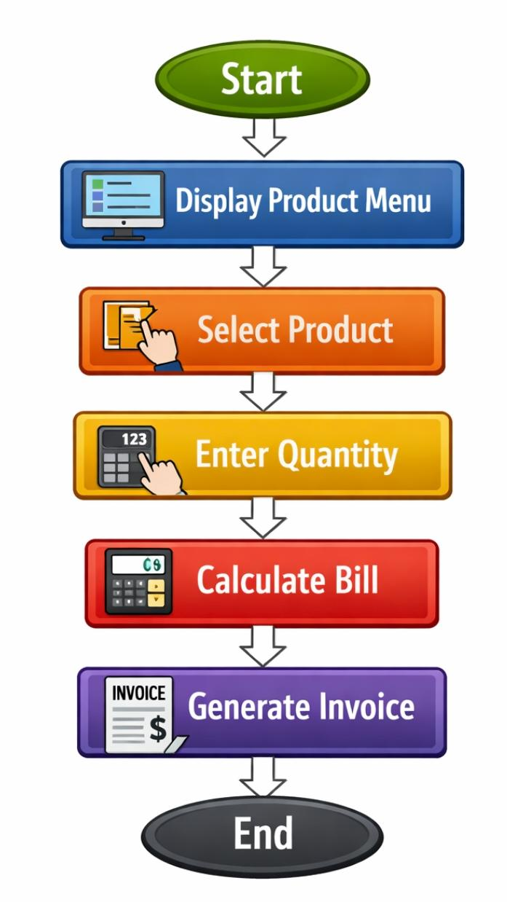
Students can draw the flowchart using:
• draw.io
• Lucidchart
• MS Visio

5.SOURCE CODE

import java.util.Scanner;
public class OnlineOrderSystem {
public static void main(String[] args) {
Scanner sc = new Scanner(System.in);
int choice, quantity;
double price = 0, total = 0, grandTotal = 0;
char more;
System.out.println("===== ONLINE ORDER PROCESSING AND INVOICE GENERATION SYSTEM =====");
do {
System.out.println("\n----------- PRODUCT MENU -----------");
System.out.println("1. Laptop - Rs 50000");
System.out.println("2. Mobile Phone - Rs 20000");
System.out.println("3. Headphones - Rs 2000");
System.out.println("4. Keyboard - Rs 1500");
System.out.println("5. Mouse - Rs 500");
System.out.print("Enter product number: ");
choice = sc.nextInt();
System.out.print("Enter quantity: ");
quantity = sc.nextInt();
switch (choice) {
case 1:
price = 50000;
break;
case 2:
price = 20000;
break;
case 3:
price = 2000;
break;
case 4:
price = 1500;
break;
case 5:
price = 500;
break;
default:
System.out.println("Invalid choice!");
price = 0;
}
total = price * quantity;
grandTotal += total;
System.out.println("Item Total = Rs " + total);

System.out.print("Do you want to order more items? (y/n): ");
more = sc.next().charAt(0);
} while (more == 'y' || more == 'Y');
System.out.println("\n=========== INVOICE ===========");
System.out.println("Total Amount to Pay: Rs " + grandTotal);
System.out.println("Thank you for your order!");
sc.close();
}
}

6.INPUT AND OUTPUT SCREENS
COMPILATION SCREEN:
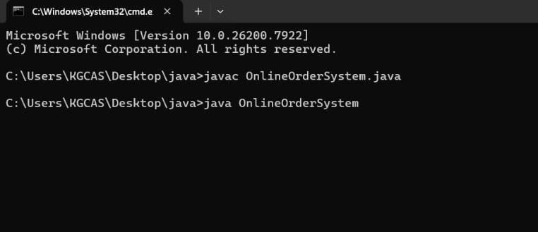
INPUT SCREEN:
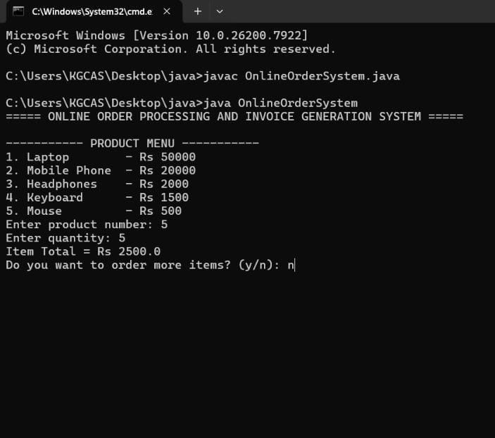

OUTPUT SCREEN:
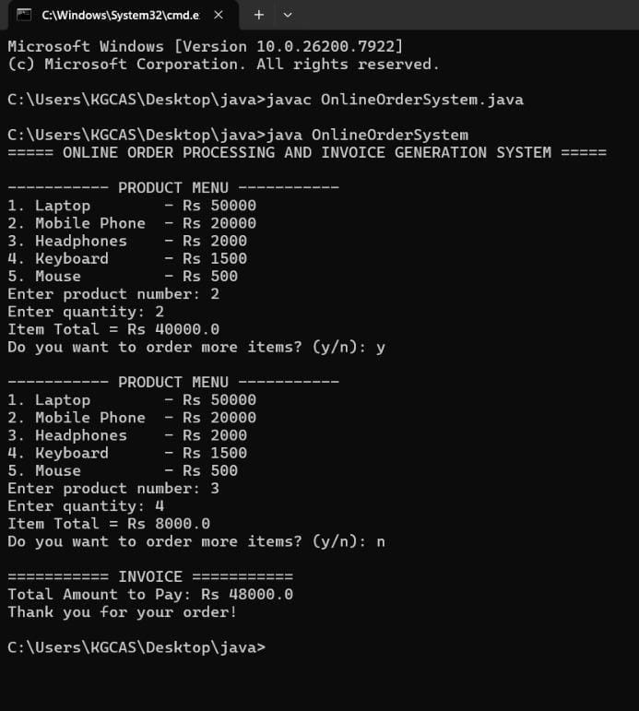

7.DISCUSSION & CONCLUSION

7.1 Discussion

The Online Order Processing and Invoice Generation System was developed to automate the order processing and billing process. The system allows users to select products, enter quantities, and generate invoices automatically.

The project applies Core Java programming concepts such as loops, conditional statements, methods, and object-oriented programming principles.

The system was tested with different inputs and successfully produced accurate invoices.

7.2 Conclusion:

The Online Order Processing and Invoice Generation System demonstrates the practical use of Java programming in developing real-world applications.
The system simplifies order processing, reduces calculation errors, and generates accurate invoices quickly. It helps businesses improve efficiency and maintain proper transaction records.
This project provides a strong foundation for developing more advanced e-commerce and billing systems in the future.

8.REFERENCES

Books
• Herbert Schildt – Java: The Complete Reference
Websites
1.https://www.oracle.com/java
2.https://www.geeksforgeeks.org
3.https://www.w3schools.com
4.https://www.javatpoint.com

